HISTORICAL SOCIETY OF PALM BEACH COUNTY
JUDGE JAMES R. KNOTT HISTORICAL CONTRIBUTION AWARD
NOMINATION FORM

Name of Nominee:__________________________________________________________________ Date:______________________

Organization Affiliation(s) if any:______________________________________________________________________________

Address: _________________________________________________________________________________________________________

City/ZIP:_________________________________________________________________________________________________________

PHONES: Office:__________________Home:___________________Cell:________________________Fax:__________________

What specific contribution has the nominee made to the preservation, promotion or enrichment of Palm Beach County history?

__________________________________________________________________________________________________________________

__________________________________________________________________________________________________________________

__________________________________________________________________________________________________________________

How will this contribution enrich future generations of Palm Beach County residents?

__________________________________________________________________________________________________________________

__________________________________________________________________________________________________________________

__________________________________________________________________________________________________________________

Name of Nominator:__________________________________________________________________________________________

Address:___________________________________________________City/ZIP:__________________________________________

PHONES: Office:__________________Home:___________________Cell:________________________Fax:_________________

Relationship to the nominee: ________________________________________________________________________________

*Please do not inform your nominee that their name has been submitted for consideration.
This form will remain confidential to the Society.

Please return this form as soon as possible to
HISTORICAL SOCIETY OF PALM BEACH COUNTY
Post Office Box 4364
West Palm Beach, FL 33402-4364
(561) 832-4164 Fax: (561) 832-7965
sposs@pbchistory.org
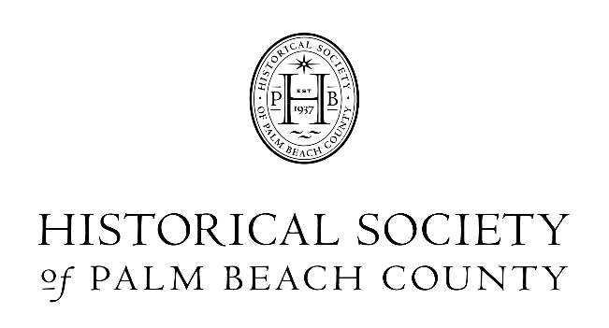

JUDGE JAMES R. KNOTT HISTORICAL CONTRIBUTION AWARD

Established in 1989, this annual award recognizes the achievements of an individual or organization that has contributed to the preservation, promotion or enrichment of Palm Beach County history. This contribution should enrich Palm Beach County residents for generations to come.
The award honors and is named for the late Honorable Judge James R. Knott who served as President of the Society from 1957 to 1969. Judge Knott is fondly remembered as a dedicated historian, author of the Brown Wrapper newspaper series and three books on the history of our area.

GUIDELINES FOR NOMINATIONS

Who may nominate? Anyone interested in Palm Beach County history may identify an individual or organization that they believe is an appropriate candidate, excluding an organization of which they are an officer, member, or employee. Nominations must be submitted on forms provided by the HSPBC, and anonymous nominations will not be accepted.
Who is eligible for nomination? The goal of this award is to recognize individuals or organizations for their contributions to the history of our county, those that have worked to preserve, promote or enrich our history for future generations. Individuals must live in Palm Beach County and organizations must serve Palm Beach County.
How many nominees will be honored with the award? Generally, the award goes annually to a single individual or organization. However, if circumstances warrant, more than one individual or organization may be honored.

Confidentiality- Nominations for this award will be made through a public nomination process. Those submitting nominations must not inform nominees that their names have been submitted for consideration. All nominations remain the confidential property of the Historical Society of Palm Beach County.
Past Honorees

1989 Bessie Wilson Dubois
1990 Barbara Hoffstot
1991 Ambassador Earl E. T. Smith
1992 Mary C. Linehan
1993 Donald W. Curl, Ph. D.
1994 Antonette Dennison, Ph. D.
1995 James A. Ponce
1996 Katharine Dickenson
1997 Frances Bourque
1998 American Methodist Episcopal Church
Episcopal Church of Bethesda-by-the-Sea
St. Edwards Catholic Church
First Presbyterian Church
Royal Poinciana Chapel
St. Paul’s AME Church
1999 The Garden Club of Palm Beach
2000 Richard J. Procyk
2001 Eliot Kleinberg
2002 Donald J. Trump

2003 Judge Marvin Mounts Jr.
2004 The Palm Beach Post
2005 The Henry Morrison Flagler Museum
2006 Yesteryear Village
2007 Palm Beach County Board of Commissioners
2008 Flagler System, Inc.
2009 Harvey E. Oyer III
2010 Jupiter Inlet Lighthouse & Museum
2011 Robert Hudson Neff
2012 Dr. Reginald J. Stambaugh
2013 Ineria E. Hadley-Hudnell
2014 L. J. Parker
2015 Palm Beach Centennial Committee
2016 Robert W. Ganger
2017 Rick Gonzalez, AIA
2018 Marion Cone
2019 Charlene Farrington
2021 Boynton Beach Historical Society
2022 Rick Rose and the Worth Avenue Association 2023 Augustus C. Mayhew III
2024 Darrell Hofheinz

