HISTORICAL SOCIETY OF PALM BEACH COUNTY
FANNIE JAMES PIONEER ACHIEVEMENT AWARD
NOMINATION FORM

Name of Nominee:______________________________________________________________Date:____

Organization Affiliation(s) if any:______________________________________________________________________________

Address: _________________________________________________________________________________________________________

City/ZIP:_________________________________________________________________________________________________________

PHONES: Office:__________________Home:___________________Cell:________________________Fax:__________________

What specific contribution has the nominee made to preserving and sharing the history of Palm Beach County’s pioneering days?

________________________________________________________________________________

________________________________________________________________________________

How will this contribution enrich future generations of Palm Beach County residents?

________________________________________________________________________________

________________________________________________________________________________

________________________________________________________________________________

________________________________________________________________________________

Name of Nominator:___________________________________________________________________________________________

Address:___________________________________________________City/ZIP:___________________________________________

PHONES: Office:__________________Home:___________________Cell:________________________Fax:__________________

Relationship to the nominee: _________________________________________________________________________________

*Please do not inform your nominee that their name has been submitted for consideration.
This form will remain confidential to the Society.

Please return this form as soon as possible to
HISTORICAL SOCIETY OF PALM BEACH COUNTY
Post Office Box 4364
West Palm Beach, FL 33402-4364
(561) 832-4164 Fax: (561) 832-7965
sposs@pbchistory.org

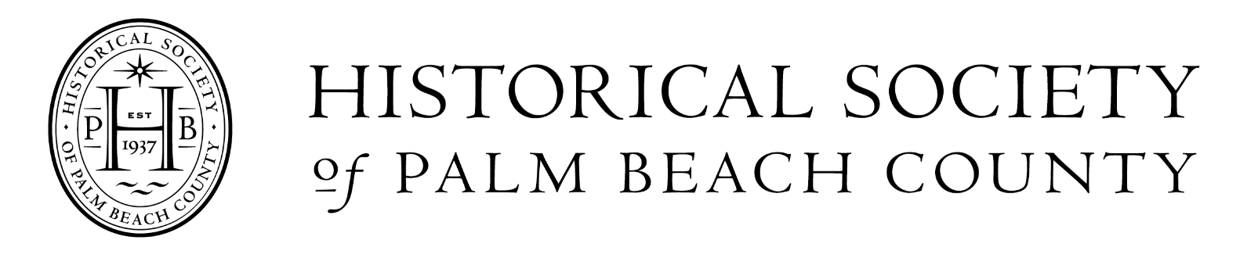

FANNIE JAMES PIONEER ACHIEVEMENT AWARD

Established in 2003, this award recognizes the achievements of individuals or organizations that have contributed to preserving and sharing the history of Palm Beach County’s pioneering days. This contribution should enrich Palm Beach County residents for generations to come.

The award honors and is named for Fannie James, an African American pioneer who served as the first post-mistress of the Jewell Post Office, which was open from 1889 until 1903. The area is now known as the City of Lake Worth.

GUIDELINES FOR NOMINATIONS

Who may nominate? Anyone interested in Palm Beach County history may identify an individual or organization that they believe is an appropriate candidate, excluding an organization of which they are an officer, member, or employee. Nominations must be submitted on forms provided by the HSPBC, and anonymous nominations will not be accepted.
Who is eligible for nomination? The goal of this award is to recognize individuals or organizations for their contributions to the history of our county, those that have worked to preserve, promote or enrich our history for future generations. Individuals must live in Palm Beach County, and organizations must serve Palm Beach County.
How many nominees will be honored with the award? Generally, the award goes annually to a single individual or organization. However, if circumstances warrant, more than one individual or organization may be honored.

Confidentiality- Nominations for this award will be made through a public nomination process. Those making nominations should not inform nominees that their names have been submitted for consideration. All nominations remain confidential property of the Historical Society of Palm Beach County.

Past Honorees

2002 Laurita Collie Sharp
2003 Robert Hazard
2004 Roy Rood
2005 Vera R. Farrington
2006 Charles Hofman
2007 Michael Bornstein
2008 Sterling/Williams
2009 Royal Poinciana Chapel
(Sea Gull Cottage)
2010 The Loxahatchee Guild
2011 Everee Jimerson Clarke
2012 Janet DeVries and Dr. Ginger Pederson
2013 Ted Brownstein
2014 Marjorie Watts Nelson
2015 Helen Vogt Greene
2016 Lake Worth Pioneers’ Association, Inc.
2017 Wells Fargo Private Bank
2018 Donald L. Kiselewski, P.E.
2019 Gina Sauber
2021 Elizabeth Stubbs Munnings
2022 Juno Beach Historical Society
2023 Boca Raton Historical Society and
The Schmidt Raton History Museum
2024 Seth Bramson

